FR_01 – Retails PA apply bulk uploads
Name | Retails PA apply bulk uploads
Description | Retails PA apply bulk uploads

FR_01_UC_01
ID | FR_01_UC_01
Use case name | PA Apply Bulk Submission
Description | PA Apply Bulk Submission
Actor(s) | - Brokers  - Sales  which their entities have bulk tool permission
Preconditions | - The user must be logged in as:  - Sales  - Brokers
Basic Flow | - User opens the action list of:  1- Personal Accident Card  - User opens the batches processes  - Bulk submission Scenario:  1- Submission with payment:  - user must attach payment slip attachment with bulk  - the xlsx file must have the fields of payment  -  2- Submission without payment>> If skip payment is eligible to the system user, he can use Submission without payment  - user must not upload the slip  - The xlsx file must not have the fields of payment  3- Operation Teams Approve/ Disapprove Scenario  - User will download the success file  - User will flag approved/disapproved policy  submission row after upload and validation  I.e. the user can accept or reject  - User upload the issuance xlsx file as batch process  As Mr Fathy scenario,  1- The Ops user can only  review the success submitted records to issuance  case by case or accept the total records of the  success file  Upload Zip File’s structure which will uploaded to:  - submission_date.xlsx  - attached “renewal_docs” directory has subdirectories, every  directory has name by national_id or passport_number and every directory has the following files:  - Id Card.png  - Passport optional.png  - Resident optional.png  I.e. The upload process is not only xlsx file, as Marina  request it as zip file which includes the mentioned files  if the records are mandatory  - The XLSX Submission Template samples  Updated here  1- Submission with payment:  - User selects opens card action list  - System displays the page of batches filter/ list  - User downloads the submission xlsx template file  - User filles the required cells in submission xlsx  - User create a .zip file with xlsx and required attachments  - User uploads the zip file to bulk submission import  - System will extract the .zip file  - System will extract the new documents attachment and save it  in related policy’s customer data  - System loops over the rows and parses the rows with  required fields of the XLSX file  and saves the success rows in the DB  - System will save the failed rows as draft flagged  - System validates required fields as normal single  process (Normal submission)  - Once the batch uploaded a new batch row will be added to  List of batches, you can see the list of batches here  - In success batches List:  - The Field Type will be: Submission with payment  - IF parsing failed in some rows and some succeeded  Then the system will generate 2 XLSX files  - Downloadable XLSX Success File  - Downloadable XLSX Failed File  - If the file succussed without parsing errors  - User can download the succeeded file only  - If the file failed totally failed to be processing  Then the system will generate the xlsx failed file only  N.B  - The attached file’s structure  1- Directory of files structure:  - Subdirectory named with national ID/Passport ID for every policy  - Every subdirectory has:  a- National ID when required in xlsx  b- Passport card when required in xlsx  c- Resident when required in xlsx  d- Payment slip when submission with payment  - All fields required for normal submission will be required  In the xlsx file uploaded  - The needed documents should follow a certain convention understood by the system & can be uploaded as a bulk.  e.g.:  - National ID: National Id should be started with word NationalID.  - Passport card: Passport card should be started with word Passport.  - Resident: Resident: should be started with word Resident:  - Payment slip: Payment slip should be started with word Payment  - Proposal: should be started with word Proposal  commercial register: should be started with Commercial_reg  - Tax id: should be started with Tax_id  The operation Response cycle with payment and with out Payment  1- Operation user can review the submission bulks  2- Operation user can approve or disapprove  the pending bulk submitted with payment policies  to be issued  3- Operation user approve by click complete the submission  - Action List contains menu items:  - View History  - Download succeeded  - Download Failed  - Approve as submission completed  - Disprove and sent it back to related distribution  channel  on click: system will flag the file as completed  - Cancel the policy in case submissions with payment>>with refund . else without Refund  - Amend the batch file and reupdate  - Amend case by case  - User has option in List action feature to reject the  policy  1- case by case (row by row) with refund or not  same as normal cycle  2 - User has option to Button to reject the file
Batches Filter/ List Page | - The page contains:  1- XLSX Templates for downloads and used in bulk upload  a- Submission template  b- Issuance template  c- Cancellation template  d- Downgrade/ Upgrade  d- Amendment template  2- Filter Panel  - Task name  - Status  Field Type: Dropdown  Options: 0- All  1- not started  2- started  3- fetching data  4- in progress  5- creating dept file  6- failed  - Date: from – to  - Batch type:  Field Type: Dropdown  Options:  1- All  2- Issuance  3- submission with payment  4- submission without payment  5- payment batch  6- Renewal  7- Upgrade/ Downgrade  8- Amendment  9-Cancellation  - Rest Button  On click: rest the filter form to defaults  - Apply Button  On click:  system loads the list with applied criteria  3- Import Panel:  A – Submission without payment  a- Submission with payment Import  Field Type: File upload  b- Issuance Import  Field Type: File upload  c- Downgrade/Upgrade  Field Type: File upload  d- Amendment  Field Type: File upload  e- Cancellation  Field Type: File upload  f- renewal  Field Type: File upload  g - Upgrade/ Downgrade  Field Type: File upload  h- payment  Field Type: File upload  4- List of Batches  Fields:  a- No#  b- Task  c Date  d- Type:  - submission  - issuance  - amendments  - cancellation  - downgrade/upgrade  - claims  e- Status:  - Failed  - Success  f- No of success  g- No of failed  - Download Action:  - Menu items:  -Download success:  On click: System force download xlsx  file which has the success rows  Download failed:  On click: System forces download xlsx file  which has the failed rows
Post Conditions
Action Rules
User interface / screens | 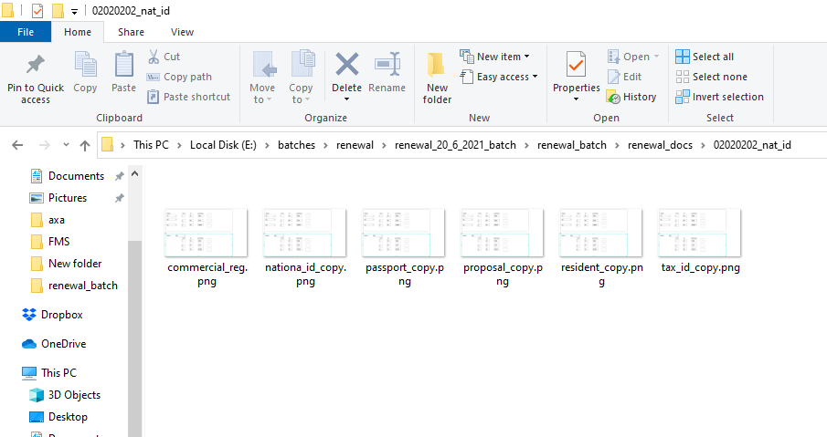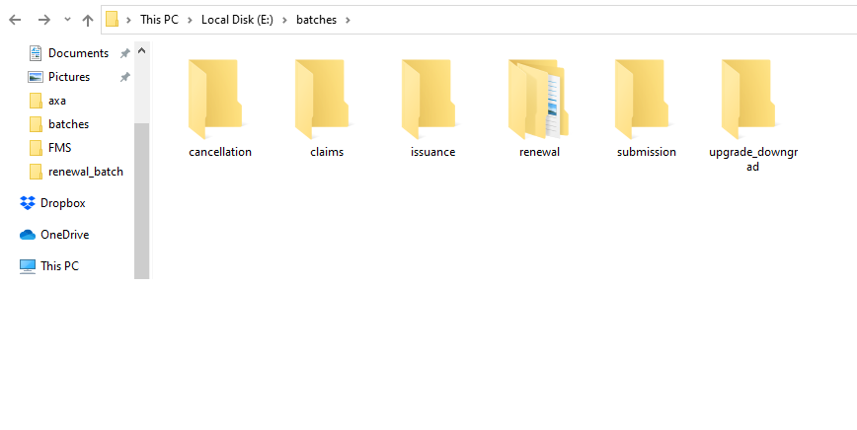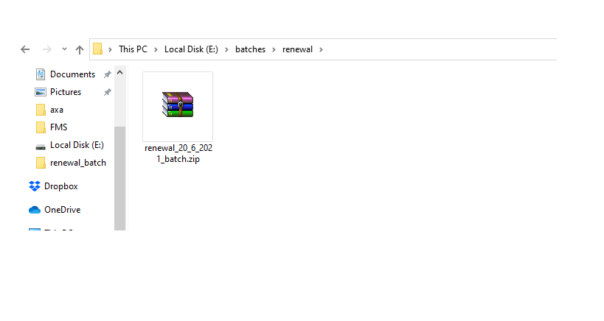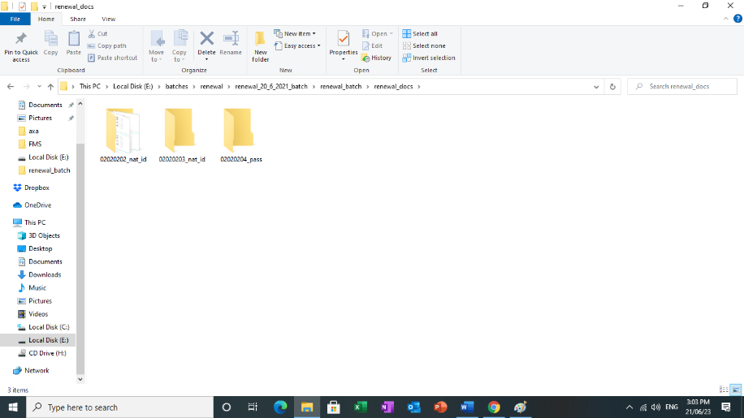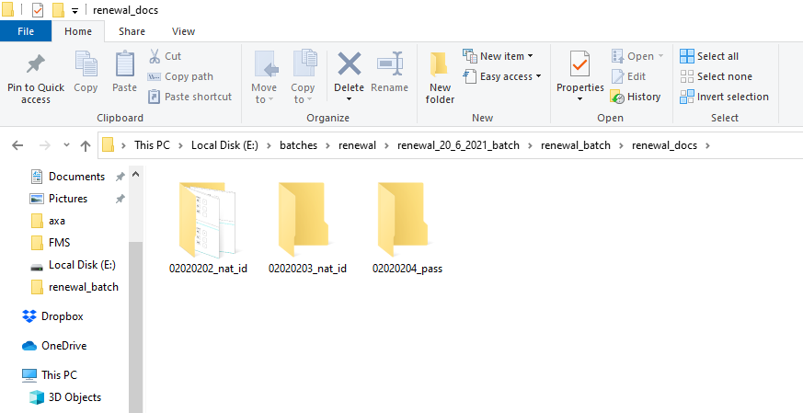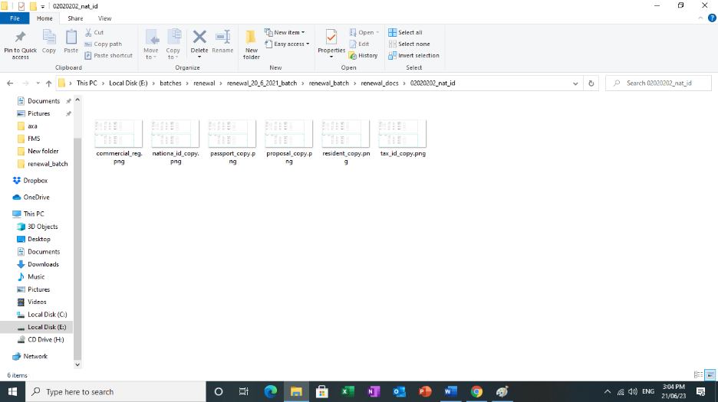

FR_01_UC_02
ID | FR_01_UC_02
Use case name | PA Apply Bulk Issuance
Description | - Operations Head  - Operations Team  - Sales>> if has issuance permission  - Broker>> if has issuance permission
Actor(s)
Preconditions | - The user must be logged in with valid permissions
Basic Flow | - User selects batches processes card’s action list  - System displays the page of batches  - which has the following fields:  1- Downloadable files Templates  2- Filter Panel  3- List Batches as table:  - #  - Task Name  - Date  Type => Issuance  - Status  - no of succeeded  - no of failed  - Download  - Delete Batch  4- Paging control  - Bulk Issuance Scenario:  - User downloads the Issuance xlsx template file  - User filles the required cells in Issuance xlsx as its format  - User attaches all required files with xlsx as zip file  - User upload the batch zip file  - System will extract the zip file as xlsx file and save others  attachment as rules  - The system issuance function will parse and validate the xlsx file and run issuance function over all rows in xlsx file  To update the DB and shown in the list of batches automatically  - The system will flag the uploaded xlsx file as follow:  In the page of batches, the list will be updated:  - #  - Task Name  - Date  Type => Issuance  - Status => completed  - no of succeeded rows  - no of failed rows  - download => download the file  1- succeeded xlsx file 2- failed xlsx file  - The failed file has the rows filed and flagged with a  specific column the reason for failed for every policy  - delete batch: only if the user will re-upload the file  this operation will reject the complete (rollback) renewal  process
Post Conditions | - Save when no errors with show success Alert  - Else Show required errors messages
Action Rules
User interface / screens | Still not found

FR_01_UC_03
ID | FR_01_UC_03
Use case name | PA Apply Bulk Renewal
Description | - Operations Head  - Operations Team  - Sales  - Broker  - CRD
Actor(s)
Preconditions | - The user must be logged in with valid permissions
Basic Flow | 1- Bulk Distribution Chanell Renewal Scenario:  - User downloads the renewal xlsx template  - User fills the required fields to xlsx file  - User attaches the documents files with xlsx file  to prepare upload the renewal process  - User uploads the zip file to the system as renewal process  - System tests and extract zip file  - System generates the 2 files  a- downloadable xlsx success file  b- downloadable xlsx failed file  2- Operations and CRD scenario:  - User review the renewal batches  - User can download the xlsx files to review  - User approve/disapprove the renewal process  - If ops user rejects the file, system will send back to  distribution user, to revalidate the file  - User can make comments  - User can renewal case by case or as one step  IF the operation is request:  The file XLSX should have a field as flag confirm that  The process is request and need to review from  Operations teams before executed as renewed  ELSE  IF the brokers, sales have permission to renew  directly, then the flag is = direct process
Post Conditions | - Save when no errors with show success Alert  - Else Show required errors messages
Action Rules
User interface / screens | Still not found

FR_01_UC_04

ID | FR_01_UC_04
Use case name | PA Apply Bulk Downgrade /Upgrade
Description | PA Apply Bulk Downgrade /Upgrade
Actor(s) | - Sales  - Brokers  - Operations Team
Preconditions | - The user must be logged in with valid permissions
Basic Flow | There are 2 scenarios in upgrade/downgrade for brokers/sales:  1- Brokers/Sales has permission to request upgrade/downgrade  - the template xlsx file flagged as request  I.e. need to be handled by operations team  2- Brokers/Sales has permission to directly upgrade/downgrade  I.e., the action will be done as bulk is processed  Bulk Downgrade /Upgrade Scenario:  1- Distribution user:  - User downloads XLSX  down/upgrade template file  - User filles up the xlsx file required  fields  - User attach the xlsx and documents  as zip file to be uploaded to the system  - User uploads the zip file  - System test and extract in success file upload process  - System parse the xlsx file and create new batch in DB  - System will generate 2 downloadable xlsx file to every  batch:  a- Failed xlsx file  b- Success xlsx file  -- Payment Cycle:  - If the user has access to process payment so:  - user can do payment using:  1- case by case from the list action feature  2- by uploading the payment slip batch file  2- Operations Team:  - User can review the Downgrade/upgrade requests  - User can download and review:  a- Failed xlsx file  b- Success xlsx file  - User can reject/accept the success files  - Accept Downgrade/Upgrade scenario will affect  Plans, products, packages, benefits, reporting
Post Conditions | - Save when no errors with show success Alert  - Else Show required errors messages
Action Rules
User interface / screens | Still not found

FR_01_UC_05
ID | FR_01_UC_05
Use case name | PA Apply Bulk Amendment and Cancellation
Description | PA Apply Bulk Amendment and Cancellation
Actor(s) | - Brokers  - Sales  - Operations Team
Preconditions | - The user must be logged in with valid permissions
Basic Flow | 1- Amendments Scenario:  a- channel user scenario:  - User downloads the amend template xlsx  - User fills the xlsx template with required data  and format  - User attaches the required documents with xlsx  - User creates zip file to be uploaded as bulk amend  process  - User uploads the zip file to system  - System tests and extract the zip file to system  - System parse the xlsx amend file as amend business  logic of amendment  - System generates 2 files xlsx:  aa- downloadable success file  bb- downloadable failed file  -with errors messages as error message field in xlsx  b- Operations User Scenario:  - User can review the amend batches  - User can accept the whole file or reject it  - User can download the success file to review the  amend file  - User can approve/disapprove the success amend  batches  - System updates the amend date  - User can review the history:  Action Menu list in the Batches List Page:  - View History  - Complete amendment  - Download Success XLSX  - Download failed XLSX  - Update policy amend status  2- Cancellation  a- user scenario:  - User downloads the cancel template xlsx  - User fills the xlsx template with required data  and format  - User attaches the required documents with xlsx  - User creates zip file to be uploaded as bulk amend  process  - User uploads the zip file to system  - System tests and extract the zip file to system  - System parse the xlsx amend file as cancel business  logic of cancellation  - System updates the cancel date  - System generates 2 files xlsx:  aa- downloadable success file  bb- downloadable failed file  -with errors messages as error message field in xlsx  - The process should apply the rules of normal refund  and normal cancel
Post Conditions | - Save when no errors with show success Alert  - Else Show required errors messages
Action Rules
User interface / screens | Still not found

FR_01_UC_06
ID | FR_01_UC_06
Use case name | PA Apply Bulk Payment update
Description | PA Apply Bulk Payment update
Actor(s) | - Brokers  - Sales  - Operations Team
Preconditions | - The user must be logged in with valid permissions
Basic Flow | - Apply Bulk Payment update  - First the distribution channel payment bulk uploads  as the zip file  - System will test and extract files:  1- IF errors found shows errors messages  and distribution channel user can upload it  again  - Else Extract zip file  - parse XLSX and save the batch to DB  - Payment updates successfully submitted flagged as  submitted, success file generated for every success  rows in the batch uploaded  - Payment updates Failed submitted flagged as failed  submitted, and XLSX failed file generated to rows  which failed in process of bulk upload  2- Operation user can review the Payment batch file  - Operation user can download the generated  payment success file or payment failed file  - approve/disapprove the payment  - Operation user can make comments  - The list of batches has new actions menu items:  - View History  - Complete  - Download success  - Download failed  N.B  Payment update:  - There should be a field dedicated to update  1- The payment status (paid, not paid)  2- payment date  3- payment actual amount  4- Commission deduction should be auto calculated and  reflected in broker’s commissions reports  - Updating the payment status should automatically  update the collection module.
Post Conditions | - Save when no errors with show success Alert  - Else Show required errors messages
Action Rules
User interface / screens | Still not found

FR_01_UC_07
ID | FR_01_UC_07
Use case name | PA Apply Bulk Save Draft
Description | - Brokers  - Sales  - Operations Team
Actor(s)
Preconditions | - The user must be logged in with valid permissions
Basic Flow | - Apply Bulk Save Draft  - This option is available in action menu of batches List  to operations teams  - The rows which are failed in batch processing can be  saved as draft xlsx file  - The Operation user can download it  N.B  - Saved to draft/Failed logs  - The operations can access both logs for the files  uploaded by the distribution channel.
Post Conditions | - Save when no errors with show success Alert  - Else Show required errors messages
Action Rules
User interface / screens | Still not found

FR_01_UC_08

ID | FR_01_UC_08
Use case name | PA Claims Bulk uploads
Description | PA Claims Bulk uploads
Actor(s) | - Claims Team
Preconditions | - The user must be logged in with valid permissions
Basic Flow
Post Conditions | - Force download  - Else Show required errors messages
Action Rules
User interface / screens | Still not found

FR_01_UC_09
ID | FR_01_UC_09
Use case name | PA Reflect Bulk uploads to Reporting
Description | PA Reflect Bulk uploads to Reporting
Actor(s) | - Finance  - Actuarial  - Operation Team Head
Preconditions | - The user must be logged in with valid permissions
Basic Flow | - Finance  1- Refund Report  2- Tape Performance  - Actuarial  1- Actuarial report  - Operation Team Head  1-Production  2- Active report  3- Pending Production Report  4- Collection report  5- Reconciliation Report  6- Due to Renewal Report  - The system should add a new field in xlsx file which differentiate  between:  a- Group Policy  b- Retails Policy  1- Actuarial Reports:  - Act user opens PA card Action list  - Act user clicks report link  - System opens report page:  - Actuarial report button  - Action Date  - Effective Date (from, to)  - Plan code  - Clear Button  - Generate Report Button  On click: create and download the XLSX file  2- Finance Reports:  - Finance user opens PA card Action list  - Finance user clicks report link  - System opens report page:  1 -Refund report  - Issue Date (from, to)  - Effective Date (from, to)  - Clear Button  - Generate Button  On click: create and download report XLSX file  2- Tape Performance  - Tape Effective (from, to)  - Clear Button  - Generate Button  On click: create and download report XLSX file  3 – Operations Team Head Reports:  - OTH user opens PA card Action list  - OTH user clicks report link  - System opens report page:  1-Production:  - Policy Action  - Action Date  - Effective Date  - Clear Button  - Generate Button  On click: create and download report XLSX file  2- Active report:  - Date (from, to)  - Clear Button  - Generate Button  On click: create and download report XLSX file  3- Pending Production Report:  - Pending Status  - Upload Date (from, to)  - Clear Button  - Generate Button  On click: create and download report XLSX file  4- Collection report  5- Reconciliation Report:  - Trails  - Payment Status  - Trails Date (from, to)  - Plan code  - Policy number  - Clear Button  - Generate Button  - Reflect Bulk uploads to all reports according to EDI Actions:  - the reports should show highlight process type of issuance  1- Individuals or 2- Batches  i.e. The reports fields will be updated with new fields as follow  1- Actuarial Report:  2- Production Report:  3-Active Report:  4-Pending Production
Post Conditions | - Force download  - Else Show required errors messages
Action Rules
User interface / screens | Still not found

